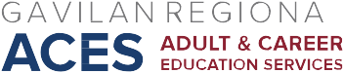

AB 104 Consortium Meeting
April 20, 2018
Agenda

- Approve December 15, March 2, and March 16, 2018, minutes

- Updates/Announcements:

- NOVA Expense Reporting for AEBG webinar: http://aebg.cccco.edu/Events/AEBG-Webinars. NOVA reporting open in early May (Quarters 1-2-3).
- Final NOVA Expense Reporting webinar: May 18, 12:00-1:30
- Regional CASAS Network Meeting @ Salinas Adult School, April 24, 9am-12pm. Focus will be on CASAS/TopsProEnterprise updates related to WIOA, some information on AEBG

- Vote on type of funding
- Vote on allocations
- Complete CFAD in NOVA and certify

Next Meeting: May 4, 2018, 2:30-4:30, ESL Computer Lab Conference Room

